Magnets On Orbit
In general NASA tries to not send magnets to the ISS. The main reason is that there is the possibility of damaging computers or other hardware. There is also a concern that a wiggling, vibrating or rotating magnet could induce electrical current in wires and send an erroneous signal.
Nearly all the panels of the station are made of aluminum so they are not attracted to the magnets. Most nuts and bolts are stainless steel so they are not attracted to the magnets. Many of the tools are steel and are attracted to the magnets but there is concern that if a socket wrench or screw driver picks up a magnetic field from being placed on a magnet, a residual magnetic field will reside on the tool and the tool could then damage a computer or other hardware.
That said, there are a few magnets that have flown. There is a strong neodymium magnet that was flown for a specific experiment but it is kept in specific places and only used with that experiment. There are warnings to keep it away from specific hardware.
There is a magnet in a standard Russian tool pouch. The magnet is weak but they made a steel backing for it that organizes the magnetic field to a more confined space so as to make it stronger and less likely to affect anything else.
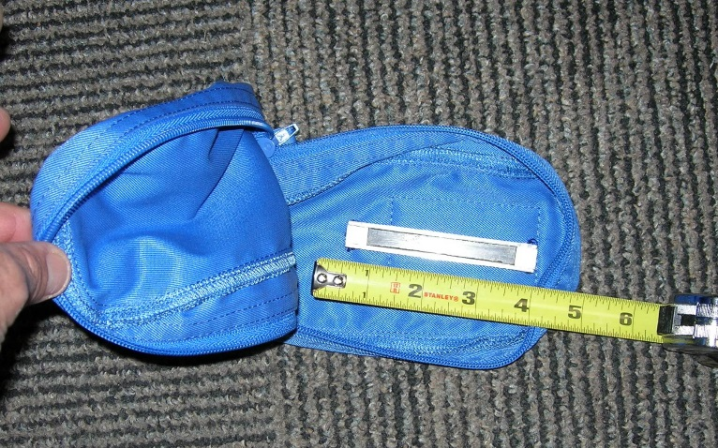
Some 12” long weak magnetic strips were flown up with patches of Velcro on the back so the crew could locate their small tools at the work site without them floating away. The crew commented that it was helpful and that some weak magnets with tools is helpful. Magnetic tape is oriented so there are stripes of North/South/ North/South which help prevent having strong magnetic fields and transferring a field to the tools. These stripes can go lengthwise with the tape or perpendicular to the length of the tape. One may be more helpful for an application than another.
